Supplementary material

Content
Model 2
Starting populations 2
Stratification 2
Parameters of the model 2
Calibration results 4
Simulation results 5
Costs 6
Chronic Asymptomatic state, treated. 6
Chronic With Cardiac Chagas Disease 7
Chronic With Digestive Chagas Disease 8
Calculation of the Incremental Net Monetary Benefit 9
Calculation of expected value of perfect information 10
References 11

Model
Figure 1. Simplified representation of the Markov model.
The model starts with a Chagas disease patient in the upper left hand corner (Chronic Asymptomatic Chagas Disease), from here a patient may develop Chronic Chagas symptomatic heart disease (Right upper corner) or chronic symptomatic Digestive disease (bottom left corner). From All the three mentioned states a patient may die and transition to the fourth state, Death (bottom right corner). The model was stratified by age group and sex.

Starting populations
Starting populations were derived from the distribution of migrants from Latin America provided by the Spanish National Institute of Statistics. Then the burden estimate of Chagas disease provided by Navarro et al. 2022¹ was used to calculate absolute numbers of cases of indeterminate chronic Chagas disease.

Stratification
The data from the Spanish National Institute of Statistics was used to stratify the patients by age group and sex. Also, to keep the population constant over time, patients that outgrew the model were added to the first age group in the next time step.

Parameters of the model
- Probability of transitioning into state with chronic chagasic cardiomyopathy.
The pre calibration value chosen from the literature was:
1.9% (95%CI, 1.3-3.0%) from Chadalawada et al. 2020.²

- After calibration, it was 1.89%, and this was used in the final CEA analysis.
- In the OWSA analysis the 1-3.0% range was used.
- In the PSA analysis 1.9% was used as the mean of a Beta distribution, with a 95% CI 1-3%. The alfa and beta parameters were estimated using the method of moments.

- Mortality due to Chagas cardiac disease.
A relative risk was used, to calculate the mortality risk of patients with cardiac disease, on top of the baseline population mortality. This relative risk was derived from the literature by dividing the yearly mortality rate reported by Chadalawada et al. 2023³, 6.3% (95% CI 4.9-8), by the yearly population mortality of the 50-55 year group, yielding 12 (95% CI 4-16).
- After calibration it was 2.57.
- In the OWSA the range used was 1.1-5.
- in the PSA 2.57 was used as a mean and 1.1-5 as the 95% CI of a lognormal distribution.
- Mortality due to Chronic Chagas digestive disease
A relative risk was used and estimated taking the values referred by Cucunubá et al. 2016.⁴ 2.1, 95% CI 1.52-2.91.
- After calibration best value was 1.25.
- In the OWSA the range used was 1-2.
- In the PSA 1.25 was used as a mean and 1-2 as the 95% CI of a lognormal distribution.

- Probability of transitioning into state with Chagas digestive disease.
The pre-calibration value chosen from the literature was: 1.1% (CI 95%, 0.8-1.36), derived from the data of Castro et al. 1994.⁵
- After calibration it was 3.5%.
- In the OWSA the range used was 1-4%.
- In the PSA 3.5% was used as the mean of a Beta distribution and 1-4% as the 95% CI. Alfa and beta were estimated using the method of moments.

- Relative risk reduction of progression to Cardiac Chagas disease
The value chosen from the literature was: 0.49 (CI 95%, 0.19-1.25), Crespillo-Andújar et al. 2022.⁶ This is not a calibrated parameter.
- In the OWSA the range used was 0.19-1.25.
- In the PSA 0.49 was used as a mean and 0.19-1.25 as the CI of a lognormal distribution.

- Relative risk reduction of progression to Digestive Chagas disease

The value chosen from the literature was: 0.88 (CI 95%, 0.55-1.42), Nunes da Costa et al. 2021.⁷ This is not a calibrated parameter.
- In the OWSA the range used was 0.55-1.42.
- In the PSA 0.88 was used as the mean and 0.55-1.42 as the 95% CI of a lognormal distribution.

Calibration results
To calibrate the model the parameters were given probability distributions, and the model was run 100000 times, Deaths due to Chagas Cardiac disease was compared to Deaths reported by Ramos-Rincón et al.⁸ The sum of the mean squared difference of the point estimates of the model output and the published data reported where used to choose the best simulation and thus the set of parameters that best fit the data. The mean squared difference was 4.63.
The best parameters were:
Probability of developing Cardiac Chagas disease: 0.018
Relative Risk of Chagas cardiac disease mortality: 2.57
Relative risk of Chagas digestive disease mortality: 1.25
Probability of developing digestive Chagas disease: 0.035
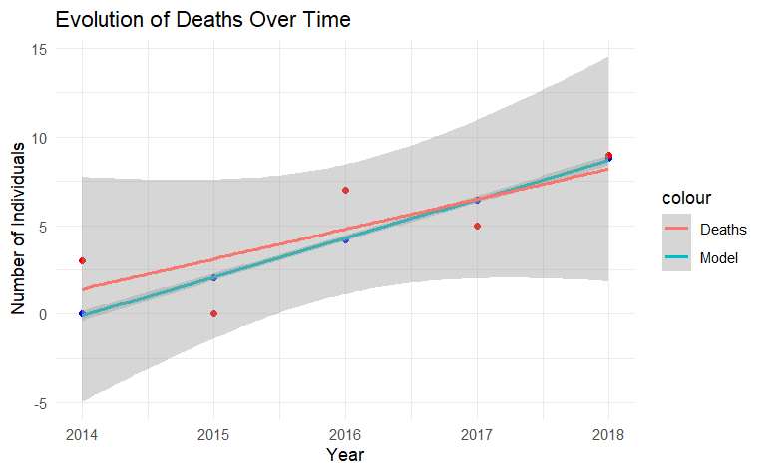

Representation of published data (in red) and modelled data (in blue) (from Ramos-Rincón et al).⁸ Lines represent linear regression lines.

Simulation results
Simulation of the untreated cohort

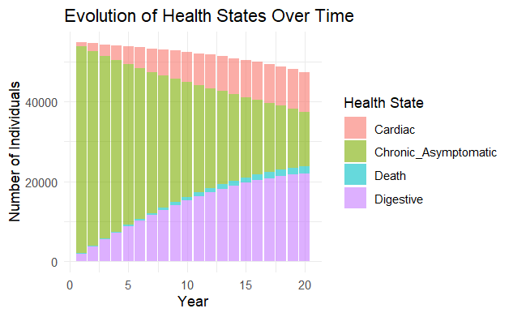
The figure above shows the evolution over time of the number of individuals in the different health states of Chagas Disease during the simulation period in the untreated arm.

Simulation of the treated cohort
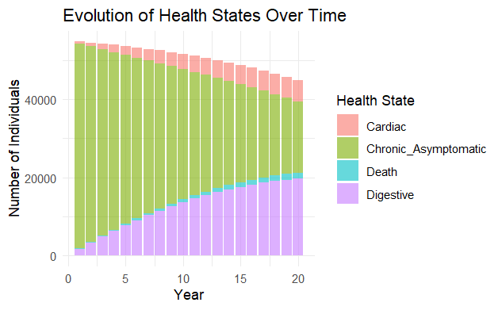
The figure above shows the evolution over time of the number of individuals in the different health states of Chagas Disease during the simulation period in the treated arm

Costs

We estimated costs for the different states as follows:

Chronic indeterminate Chagas disease state, treated.
This state represents patients infected with Trypanosoma cruzi but have not yet developed organ affectation. The costs include treatment, that is only applied in untreated simulations, and cost of follow-up and treatment of complications derived from untreated disease. These costs are applied according to the reported frequency of these complications in the different published Spanish cohorts.

Item | Unit Cost (€) | Annual Units | Annual Cost (€) | Source
Treatment | 131.00 | Once | 7.00 | Direct query to the Department of foreign medicines of the Spanish Agency of Medicines and Medical Devices.
Complete Blood Count (CBC) | 10.00 | 2 | 20.00 | BOJA 2024.⁹
Basic Biochemistry | 20.00 | 2 | 40.00 | BOJA 2024.⁹
ECG | 40.00 | 2 | 80.00 | BOJA 2024.⁹
Echocardiogram | 100.00 | 0.05 | 5.00 | BOJA 2024.⁹
Trypanosoma cruzi Serology | 20.00 | 2 | 40.00 | BOE 2023.¹⁰
Trypanosoma cruzi PCR | 44.26 | 2 | 88.52 | BOE 2023.¹⁰
Cardiac Pacemaker (MCP) | 6,000.00 | 0 | 0.00 | BOJA 2024.⁹
Heart Transplant | 100,000.00 | 0 | 0.00 | BOJA 2024.⁹
Implantable Cardioverter Defibrillator (ICD) | 25,000.00 | 0 | 0.00 | BOJA 2024.⁹
Ventricular Assist Device (VAD) | 60,000.00 | 0 | 0.00 | BOJA 2024.⁹
Barium Enema | 80.00 | 0.05 | 4.00 | BOJA 2024.⁹
Esophageal barium swallow study | 90.00 | 0.05 | 4.50 | BOJA 2024.⁹
Gastroscopy | 150.00 | 0 | 0.00 | BOJA 2024.⁹
Medical Consultation | 98.00 | 2 | 196.00 | BOJA 2024.⁹
Total |  |  | 478.02
BOJA: explicar abreviatura

Chronic chagasic cardiomyopathy
This state represents patients infected with Trypanosoma cruzi that have developed Cardiac affectation. The costs include follow-up costs, drug costs, procedures and diverse cardiac devices. These costs are applied according to the reported frequency of these complications in the different published Spanish cohorts.

Item | Unit Cost (€) | Annual Units | Annual Cost (€) | Source
Complete Blood Count (CBC) | 10.00 | 2 | 20.00 | BOJA 2024.⁹
Basic Biochemistry | 20.00 | 2 | 40.00 | BOJA 2024.⁹
ECG | 40.00 | 2 | 80.00 | BOJA 2024.⁹
Echocardiogram | 100.00 | 1 | 100.00 | BOJA 2024.⁹
Trypanosoma cruzi Serology | 20.00 | 2 | 40.00 | BOE 2023.¹⁰
Trypanosoma cruzi PCR | 44.26 | 2 | 88.52 | BOE 2023.¹⁰
Cardiac Pacemaker (MCP) | 6,000.00 | 0.02 | 120.00 | BOJA 2024.⁹
Heart Transplant | 100,000.00 | 0.01 | 1,000.00 | BOJA 2024.⁹
Implantable Cardioverter Defibrillator (ICD) | 25,000.00 | 0.03 | 750.00 | BOJA 2024.⁹
Ventricular Assist Device (VAD) | 60,000.00 | 0 | 0.00 | BOJA 2024.⁹
Barium Enema | 80.00 | 1 | 80.00 | BOJA 2024.⁹
Barium Esophageal Transit Study | 90.00 | 1 | 90.00 | BOJA 2024.⁹
Gastroscopy | 150.00 | 1 | 150.00 | BOJA 2024.⁹
Medical Consultation | 98.00 | 2 | 196.00 | BOJA 2024.⁹
Sacubitril/Valsartan | 705.21 | 12 | 8,462.52 | Spanish retail price
Bisoprolol | 5.93 | 12 | 71.16 | Spanish retail price
Dapagliflozin | 46.02 | 12 | 552.24 | Spanish retail price
Furosemide | 2.25 | 12 | 27.00 | Spanish retail price
Hospitalization | 2,727.32 | 0.04 | 109.09 | Spanish retail price
Total |  |  | 11,976.53

Chronic With Digestive Chagas Disease
This state represents patients infected with Trypanosoma cruzi that have developed digestive involvement. The costs include follow-up costs, drug costs and diverse procedures. These costs are applied according to the reported frequency of these complications in the different published Spanish cohorts.

Item | Unit Cost (€) | Annual Units | Annual Cost (€) | Source
Complete Blood Count (CBC) | 10.00 | 2 | 20.00 | BOJA 2024.⁹
Basic Biochemistry | 20.00 | 2 | 40.00 | BOJA 2024.⁹
ECG | 40.00 | 2 | 80.00 | BOJA 2024.⁹
Echocardiogram | 100.00 | 1 | 100.00 | BOJA 2024.⁹
Trypanosoma cruzi Serology | 20.00 | 2 | 40.00
Trypanosoma cruzi PCR | 44.26 | 2 | 88.52
Cardiac Pacemaker (MCP) | 6,000.00 | 0 | 0.00 | BOJA 2024.⁹
Heart Transplant | 100,000.00 | 0 | 0.00 | BOJA 2024.⁹
Implantable Cardioverter Defibrillator (ICD) | 25,000.00 | 0 | 0.00 | BOJA 2024.⁹
Ventricular Assist Device (VAD) | 60,000.00 | 0 | 0.00 | BOJA 2024.⁹
Barium Enema | 80.00 | 1 | 80.00 | BOJA 2024.⁹
Barium Esophageal Transit Study | 90.00 | 1 | 90.00 | BOJA 2024.⁹
Gastroscopy | 150.00 | 1 | 150.00 | BOJA 2024.⁹
Esophageal Manometry | 1,955.00 | 0.05 | 97.75 | BOJA 2024.⁹
Surgery | 6,277.00 | 0.01 | 62.77 | BOJA 2024.⁹
Endoscopic Sphincterotomy | 978.00 | 0.01 | 9.78 | BOJA 2024.⁹
Medical Consultation | 98.00 | 2 | 196.00 | BOJA 2024.⁹
Total |  |  | 858.82

Calculation of the Incremental Net Monetary Benefit

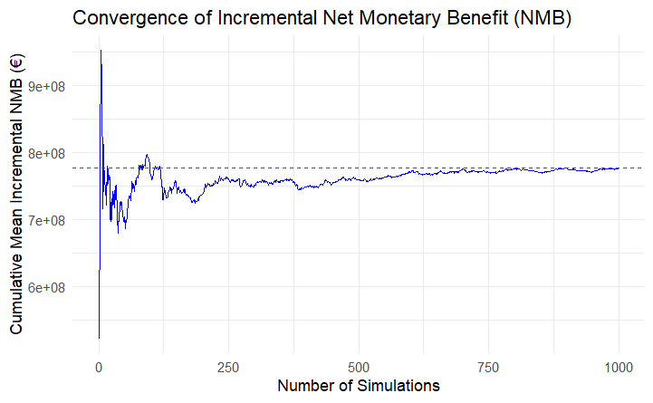

Figure: Convergence plot of the cumulative mean incremental Net Monetary Benefit (NMB) over the number of probabilistic sensitivity analysis simulations. The red dashed line indicates the overall mean incremental NMB. The plot suggests that the estimate stabilizes after approximately 700–800 simulations, supporting the adequacy of the chosen sample size for decision-making.

Calculation of expected value of perfect information
This calculation is undertaken taking using the results of the probabilistic sensitivity analysis.
First we calculate the Net Monetary Benefit (NMB =(WTP×QALYs)−Cost ) for each iteration. Then we calculate the mean of the NMB for each strategy and then we choose the strategy with the highest expected value. This is the Expected Value with Current Information (EVwCI).
On the other hand we calculate the Expected Value with Perfect Information (EVwPI), which is obtained taking the mean of the strategy with highest NMB for each iteration.
The difference between the two, would be the value of perfect information and it represents the maximum the health care system should be willing to pay for additional information to make a better decision.

References

1 Navarro M, Reguero L, Subirà C, Blázquez-Pérez A, Requena-Méndez A. Estimating chagas disease prevalence and number of underdiagnosed, and undertreated individuals in Spain. Travel Med Infect Dis 2022; 47: 102284.
2 Chadalawada S, Sillau S, Archuleta S, et al. Risk of Chronic Cardiomyopathy Among Patients With the Acute Phase or Indeterminate Form of Chagas Disease: A Systematic Review and Meta-analysis. JAMA Netw Open 2020; 3: e2015072.
3 Chadalawada S, Rassi A, Samara O, et al. Mortality risk in chronic Chagas cardiomyopathy: a systematic review and meta‐analysis. ESC Heart Fail 2021; 8: 5466–81.
4 Cucunubá ZM, Okuwoga O, Basáñez M-G, Nouvellet P. Increased mortality attributed to Chagas disease: a systematic review and meta-analysis. Parasit Vectors 2016; 9: 42.
5 Castro C, Macêdo V, Rezende JM, Prata A. Estudo radiológico longitudinal do esôfago, em área endêmica de doença de Chagas, em um período de 13 anos. Rev Soc Bras Med Trop 1994; 27: 227–33.
6 Crespillo-Andújar C, Comeche B, Hamer DH, et al. Use of benznidazole to treat chronic Chagas disease: An updated systematic review with a meta-analysis. PLoS Negl Trop Dis 2022; 16: e0010386.
7 Nunes Da Costa EAP, Victória C, Fortaleza CMCB. Predictors of development of cardiac and digestive disorders among patients with indeterminate chronic Chagas Disease. PLoS Negl Trop Dis 2021; 15: e0009680.
8 Ramos-Rincon J-M, Llenas-García J, Pinargote-Celorio H, et al. Chagas Disease-Related Mortality in Spain, 1997 to 2018. Microorganisms 2021; 9: 1991.
9 Consejería de salud. Orden de 24 de mayo de 2024, por la que se establece el importe de los servicios, actividades y bienes de naturaleza sanitaria, prestados en centros sanitarios del Sistema Sanitario Público de Andalucía, que deben ser retribuidos mediante precios públicos por los terceros obligados legalmente al pago. 2024.
10Ministerio de Ciencia e innovación. Resolución de 14 de noviembre de 2023, del Instituto de Salud Carlos III, O.A., M.P., por la que se modifica el Anexo de la Resolución de 3 de abril de 2019, por la que se establecen los precios públicos correspondientes a la prestación de servicios y actividades del organismo. Bol Of Estado 2023; published online Dec 5.

